Project Design Phase-II
Data Flow Diagram & User Stories

Date | 05-12-2025
Project Name | FlightHub - Flight Booking Application
Maximum Marks | 4 Marks

Data Flow Diagrams: A Data Flow Diagram (DFD) illustrates how data flows within the SkyWings Flight Booking System. It shows how users (customers) and administrators interact with the system, how flight-related data is processed between components, and how it is stored securely in the database.
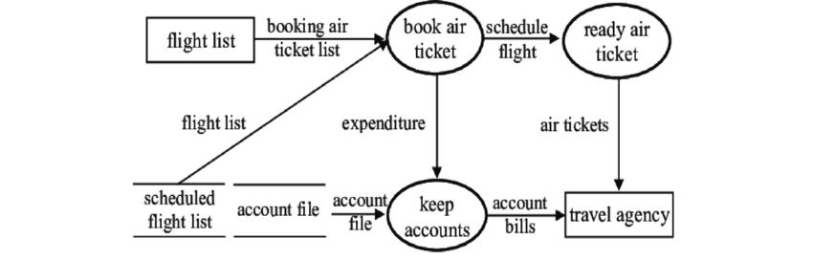

The major modules include user authentication, flight search & filtering, booking & payments, and admin flight management.
User Stories
User Story Table –Bookstore Platform
User Type | Functional Requirement (Epic) | User Story / Task | Acceptance Criteria | Priority | Release
User |  | As a user, I can sign up and log in securely. | Login success redirects to homepage. | High | Sprint-1
  User Authentication
User |  | As a user, I can reset my password if forgotten. | Reset link sent and password updated. | Medium | Sprint-1
  Password Reset
User | Flight Search |  | Search returns relevant results instantly. | High | Sprint-2
  As a user, I can search flights by origin, destination, date, and class.
User | Flight Details | As a user, I can view complete flight details (timings, prices, seats). | Correct flight details displayed. | Medium | Sprint-2
User | Booking & Payment | As a user, I can books a flight and make secure payment. | Payment succeeds and tickets is confirmed. | High | Sprint-3
User | Booking History | As a user, I can make secure payments and place orders. | Payment processed and order shown in history. | High | Sprint-3
User |  | As a user, I can cancel my booked flight. | Bookings list displays accurately. | Medium | Sprint-4
  Cancel Booking
Admin | Admin Dashboard | As an admin, I can access an exclusive admin panel. | Ticket status updates to “Cancelled”. | Medium | Sprint-1
Admin | Flight Management | As an admin, I can add, update, and delete flights. | Logged-in admin redirects to dashboard. | High | Sprint-2
Admin | View All Bookings | As an admin, I can view bookings made by all users. | All bookings appear with correct information. | Medium | Sprint-3

User stories are mapped to sprints to ensure predictable delivery of core modules. High-priority features such as authentication, flight search, and booking/payment are developed earlier, while medium-priority features like cancellation and booking history are implemented in later sprints.

